## Diabetes Dataset

### Objective

The objective of the dataset is to diagnostically predict whether or not a patient has diabetes

#### Import pandas, numpy, seaborn, matplotlib.pyplot packages

In [2]:

**import** numpy **as** np

**import** pandas **as** pd

**import** matplotlib.pyplot **as** plt

**%**matplotlib inline

**import** seaborn **as** sns

**from** warnings **import** filterwarnings

filterwarnings('ignore')

In [3]:

df **=** pd.read_csv('Datasets/diabetes.csv')

df.head()

Out[3]:

|  |  |  |  |  |  |  |  |  |  |
| --- | --- | --- | --- | --- | --- | --- | --- | --- | --- |
|  | **Pregnancies** | **Glucose** | **BloodPressure** | **SkinThickness** | **Insulin** | **BMI** | **DiabetesPedigreeFunction** | **Age** | **Outcome** |
| **0** | 6 | 148 | 72 | 35 | 0 | 33.6 | 0.627 | 50 | 1 |
| **1** | 1 | 85 | 66 | 29 | 0 | 26.6 | 0.351 | 31 | 0 |
| **2** | 8 | 183 | 64 | 0 | 0 | 23.3 | 0.672 | 32 | 1 |
| **3** | 1 | 89 | 66 | 23 | 94 | 28.1 | 0.167 | 21 | 0 |
| **4** | 0 | 137 | 40 | 35 | 168 | 43.1 | 2.288 | 33 | 1 |

**It is a Classification Problem - the Dependent variable is Outcome**

* **Shape of Dataset**

In [4]:

df.shape

Out[4]:

(768, 9)

* **The dataset has total 768 rows & 9 Attributes**
* **Checking Information of Dataset**

In [5]:

df.info()

<class 'pandas.core.frame.DataFrame'>  
RangeIndex: 768 entries, 0 to 767  
Data columns (total 9 columns):  
 # Column Non-Null Count Dtype   
--- ------ -------------- -----   
 0 Pregnancies 768 non-null int64   
 1 Glucose 768 non-null int64   
 2 BloodPressure 768 non-null int64   
 3 SkinThickness 768 non-null int64   
 4 Insulin 768 non-null int64   
 5 BMI 768 non-null float64  
 6 DiabetesPedigreeFunction 768 non-null float64  
 7 Age 768 non-null int64   
 8 Outcome 768 non-null int64   
dtypes: float64(2), int64(7)  
memory usage: 54.1 KB

* Dataset has 2 Float columns, 7 integer columns

## Data preprocessing & EDA

#### checking null values

In [6]:

df.isnull().sum()

Out[6]:

Pregnancies 0  
Glucose 0  
BloodPressure 0  
SkinThickness 0  
Insulin 0  
BMI 0  
DiabetesPedigreeFunction 0  
Age 0  
Outcome 0  
dtype: int64

* There is no null values

**Plotting Histogram**

In [7]:

df.hist(figsize**=**(10,10))

plt.show()

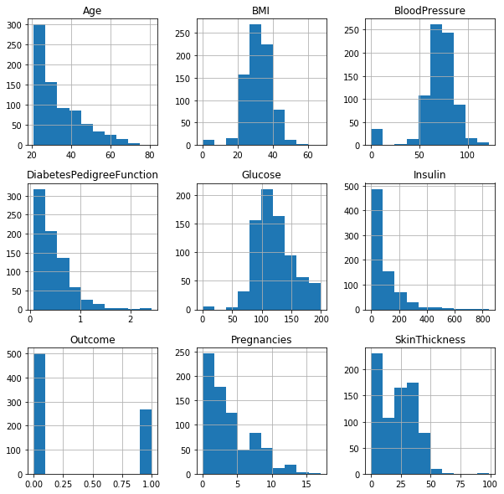

### Inference from Histogram:

* Outcome Categorical Variables which is in Encoded format

### Checking for outliers

In [8]:

df.columns

Out[8]:

Index(['Pregnancies', 'Glucose', 'BloodPressure', 'SkinThickness', 'Insulin',  
 'BMI', 'DiabetesPedigreeFunction', 'Age', 'Outcome'],  
 dtype='object')

In [10]:

col **=** ['Pregnancies', 'Glucose', 'BloodPressure', 'SkinThickness', 'Insulin',

'BMI', 'DiabetesPedigreeFunction', 'Age']

**for** i **in** col:

sns.boxplot(df[i])

plt.show()

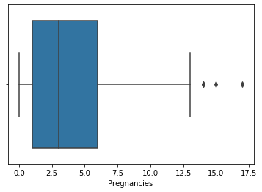

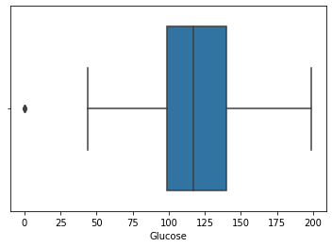

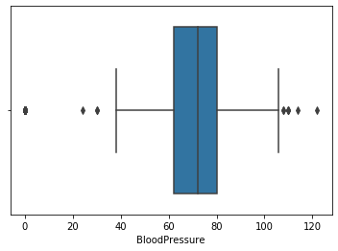

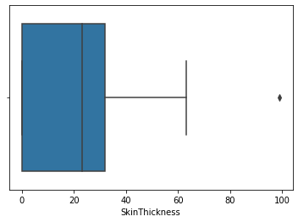

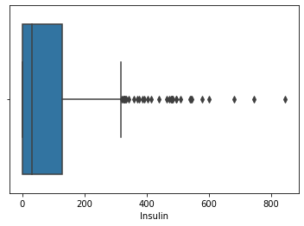

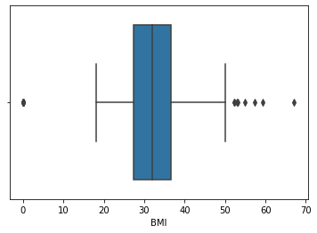

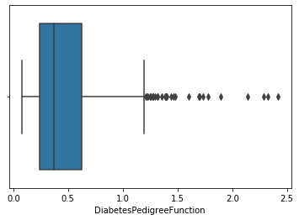

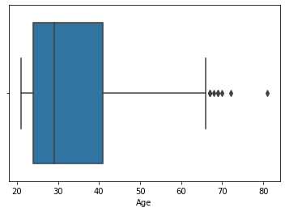

#### There are moderate outliers

## Correlation matrix

In [9]:

plt.figure(figsize**=**(10,8))

sns.heatmap(df.corr(), annot **=** **True**)

Out[9]:

<matplotlib.axes._subplots.AxesSubplot at 0x1bc04253148>

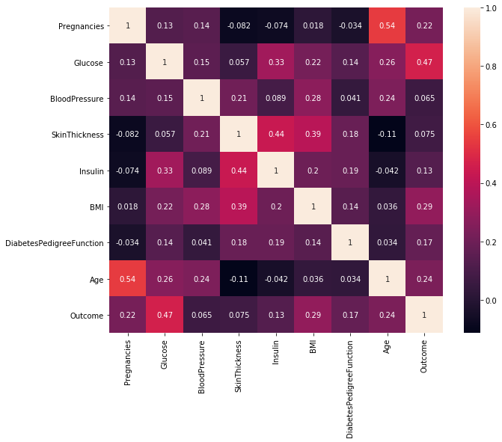

### Analysis

In [46]:

df['Outcome'].value_counts()

Out[46]:

0 500  
1 268  
Name: Outcome, dtype: int64

In [37]:

df['Outcome'].value_counts().plot(kind**=**'pie', autopct **=** "%1.0f%%")

Out[37]:

<matplotlib.axes._subplots.AxesSubplot at 0x22c6d684448>

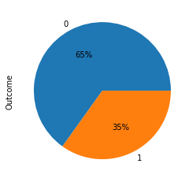

### Inference:

* 35% of the persons in dataset have diabetes

In [39]:

sns.pairplot(df, hue**=**'Outcome')

Out[39]:

<seaborn.axisgrid.PairGrid at 0x22c6f76ef88>

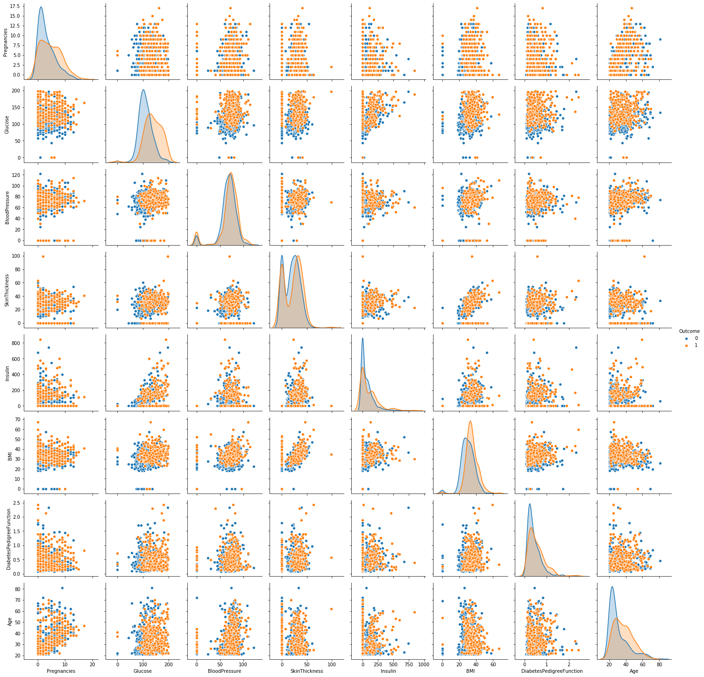

In [42]:

colm **=** ['Pregnancies', 'Glucose', 'BloodPressure', 'SkinThickness', 'Insulin',

'BMI', 'DiabetesPedigreeFunction', 'Age']

**for** col **in** colm:

sns.distplot(df[col])

plt.show()

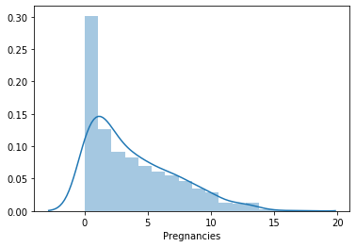

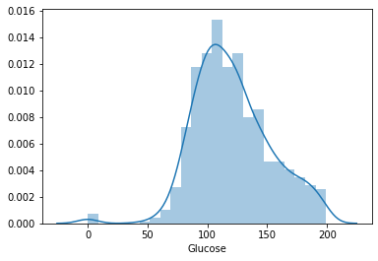

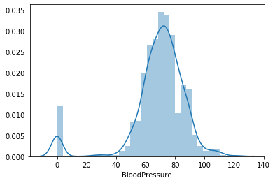

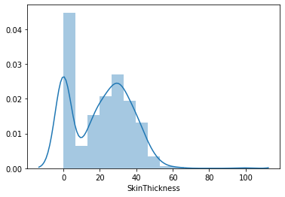

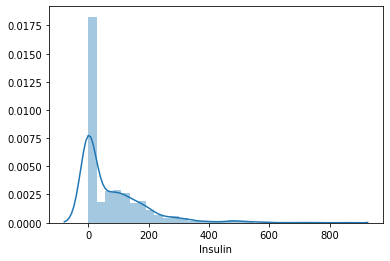

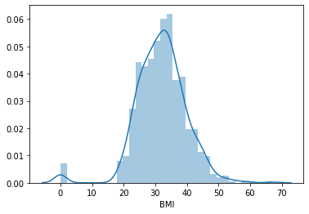

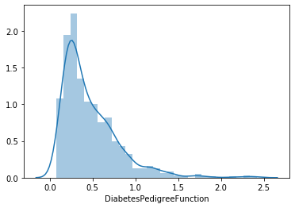

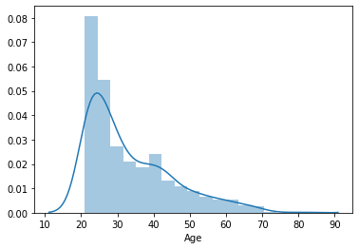

### Inference from Distplot

* Pregnencies, Glucose, Insulin , DiabetesPedigreeFunction, Age is Unimodal
* BloodPresure, SkinThickness, BMI from Home is Bimodal

In [43]:

sns.barplot(df['Pregnancies'], df['Glucose'])

Out[43]:

<matplotlib.axes._subplots.AxesSubplot at 0x22c74ebcd48>

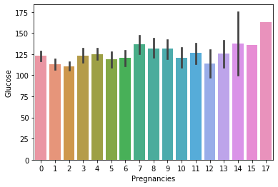

In [45]:

sns.pointplot(df['Pregnancies'], df['Glucose'])

Out[45]:

<matplotlib.axes._subplots.AxesSubplot at 0x22c75149dc8>

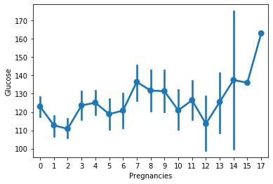

In [47]:

pd.crosstab(df.Outcome , df.Pregnancies)

Out[47]:

|  |  |  |  |  |  |  |  |  |  |  |  |  |  |  |  |  |  |
| --- | --- | --- | --- | --- | --- | --- | --- | --- | --- | --- | --- | --- | --- | --- | --- | --- | --- |
| **Pregnancies** | **0** | **1** | **2** | **3** | **4** | **5** | **6** | **7** | **8** | **9** | **10** | **11** | **12** | **13** | **14** | **15** | **17** |
| **Outcome** |  |  |  |  |  |  |  |  |  |  |  |  |  |  |  |  |  |
| **0** | 73 | 106 | 84 | 48 | 45 | 36 | 34 | 20 | 16 | 10 | 14 | 4 | 5 | 5 | 0 | 0 | 0 |
| **1** | 38 | 29 | 19 | 27 | 23 | 21 | 16 | 25 | 22 | 18 | 10 | 7 | 4 | 5 | 2 | 1 | 1 |

In [55]:

sns.pointplot(df['Pregnancies'], df['Outcome'])

Out[55]:

<matplotlib.axes._subplots.AxesSubplot at 0x22c790a8d88>

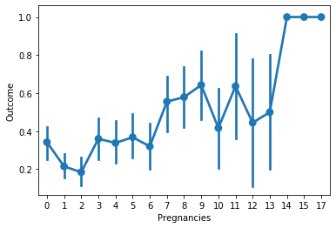

### Spliting data

In [15]:

x **=** df.drop(['Outcome'], axis**=**1)

x.head()

Out[15]:

|  |  |  |  |  |  |  |  |  |
| --- | --- | --- | --- | --- | --- | --- | --- | --- |
|  | **Pregnancies** | **Glucose** | **BloodPressure** | **SkinThickness** | **Insulin** | **BMI** | **DiabetesPedigreeFunction** | **Age** |
| **0** | 6 | 148 | 72 | 35 | 0 | 33.6 | 0.627 | 50 |
| **1** | 1 | 85 | 66 | 29 | 0 | 26.6 | 0.351 | 31 |
| **2** | 8 | 183 | 64 | 0 | 0 | 23.3 | 0.672 | 32 |
| **3** | 1 | 89 | 66 | 23 | 94 | 28.1 | 0.167 | 21 |
| **4** | 0 | 137 | 40 | 35 | 168 | 43.1 | 2.288 | 33 |

In [16]:

y **=** df.iloc[:,**-**1:]

y.head()

Out[16]:

|  |  |
| --- | --- |
|  | **Outcome** |
| **0** | 1 |
| **1** | 0 |
| **2** | 1 |
| **3** | 0 |
| **4** | 1 |

### Split into test and train dataset (70-30 ratio)

In [17]:

**from** sklearn.model_selection **import** train_test_split

x_train, x_test, y_train, y_test **=** train_test_split(x,y,test_size**=**0.3,random_state**=**0)

In [18]:

print("Dataset shape:", df.shape)

print("Input Features shape: ", x_train.shape, y_train.shape)

print("Output Features shape: ", x_test.shape, y_test.shape)

Dataset shape: (768, 9)  
Input Features shape: (537, 8) (537, 1)  
Output Features shape: (231, 8) (231, 1)

### Applying Logistic Regression

In [19]:

**from** sklearn.linear_model **import** LogisticRegression

log **=** LogisticRegression()

#### Fitting model

In [20]:

log.fit(x_train,y_train)

Out[20]:

LogisticRegression(C=1.0, class_weight=None, dual=False, fit_intercept=True,  
 intercept_scaling=1, l1_ratio=None, max_iter=100,  
 multi_class='auto', n_jobs=None, penalty='l2',  
 random_state=None, solver='lbfgs', tol=0.0001, verbose=0,  
 warm_start=False)

#### Predicting values

In [21]:

pred **=** log.predict(x_test)

In [17]:

pred

Out[17]:

array([1, 0, 0, 1, 0, 0, 1, 1, 0, 0, 1, 1, 0, 0, 0, 0, 1, 0, 0, 0, 1, 0,  
 0, 0, 0, 0, 0, 1, 0, 0, 0, 0, 0, 0, 0, 1, 0, 0, 0, 1, 0, 0, 0, 1,  
 1, 0, 0, 0, 0, 0, 0, 0, 1, 1, 0, 0, 0, 1, 0, 0, 1, 0, 0, 1, 1, 1,  
 1, 0, 0, 0, 0, 0, 0, 1, 1, 0, 0, 1, 0, 0, 0, 0, 0, 0, 0, 0, 0, 0,  
 1, 0, 0, 0, 0, 0, 1, 0, 0, 1, 1, 0, 0, 0, 0, 0, 1, 0, 0, 0, 0, 1,  
 0, 0, 1, 0, 1, 1, 0, 1, 0, 1, 0, 0, 0, 0, 0, 0, 0, 0, 0, 0, 0, 0,  
 0, 1, 0, 0, 0, 0, 1, 0, 0, 1, 0, 0, 0, 0, 0, 0, 0, 0, 0, 1, 0, 0,  
 1, 0, 1, 0, 0, 1, 1, 1, 0, 0, 1, 0, 0, 0, 0, 0, 0, 0, 0, 0, 1, 0,  
 0, 0, 0, 0, 0, 1, 0, 1, 0, 0, 1, 0, 0, 0, 0, 0, 0, 0, 0, 1, 1, 0,  
 0, 0, 0, 0, 0, 0, 0, 0, 0, 0, 0, 0, 0, 0, 0, 0, 0, 0, 0, 0, 1, 0,  
 0, 0, 0, 1, 1, 1, 0, 0, 0, 0, 0], dtype=int64)

#### Finding accuracy score and confusion matrix

In [22]:

**from** sklearn.metrics **import** accuracy_score, confusion_matrix

In [23]:

accuracy_score(y_test,pred, normalize**=True**)

Out[23]:

0.7792207792207793

In [24]:

confusion_matrix(y_test,pred)

Out[24]:

array([[141, 16],  
 [ 35, 39]], dtype=int64)

In [ ]:

## Applying KNN

In [25]:

**from** sklearn.neighbors **import** KNeighborsClassifier

knn **=** KNeighborsClassifier()

#### Fitting model

In [26]:

knn.fit(x_train,y_train)

Out[26]:

KNeighborsClassifier(algorithm='auto', leaf_size=30, metric='minkowski',  
 metric_params=None, n_jobs=None, n_neighbors=5, p=2,  
 weights='uniform')

#### Predicting values

In [27]:

ypred **=** knn.predict(x_test)

In [28]:

ypred

Out[28]:

array([1, 0, 0, 1, 0, 0, 1, 1, 0, 0, 1, 1, 0, 0, 0, 0, 1, 0, 1, 0, 0, 0,  
 0, 0, 0, 0, 0, 1, 0, 0, 1, 0, 0, 1, 0, 1, 1, 0, 0, 0, 0, 0, 0, 1,  
 1, 0, 0, 0, 0, 0, 0, 0, 1, 0, 0, 0, 0, 0, 0, 0, 1, 0, 0, 1, 1, 1,  
 1, 0, 1, 0, 0, 0, 0, 1, 1, 0, 0, 1, 0, 0, 0, 0, 0, 0, 0, 0, 0, 0,  
 1, 0, 0, 0, 0, 0, 1, 0, 0, 1, 0, 1, 0, 0, 0, 0, 0, 0, 0, 0, 0, 1,  
 0, 0, 1, 0, 1, 1, 0, 1, 0, 1, 1, 1, 0, 0, 0, 0, 0, 1, 1, 1, 0, 0,  
 0, 1, 0, 0, 0, 0, 1, 1, 0, 1, 0, 0, 1, 0, 0, 0, 0, 0, 0, 0, 0, 0,  
 1, 0, 1, 0, 0, 1, 1, 1, 0, 0, 1, 0, 0, 0, 1, 0, 0, 0, 0, 1, 0, 0,  
 0, 0, 0, 0, 0, 1, 0, 1, 0, 0, 1, 0, 0, 0, 0, 0, 0, 0, 0, 1, 1, 1,  
 0, 0, 0, 0, 0, 0, 0, 0, 0, 0, 0, 0, 0, 0, 0, 0, 0, 0, 0, 0, 0, 0,  
 0, 0, 0, 0, 1, 1, 0, 0, 0, 0, 1], dtype=int64)

#### Finding accuracy score and confusion matrix

In [29]:

accuracy_score(y_test, ypred, normalize**=True**)

Out[29]:

0.7489177489177489

In [30]:

confusion_matrix(y_test, ypred)

Out[30]:

array([[134, 23],  
 [ 35, 39]], dtype=int64)

## Conclusion

KNN with k=5 has the accuracy of 74.89% on test dataset while Logistic Regression is having 77.92% accuracy on test dataset

Hence, Logistic Regression is predicting more accurately than KNN